**Assignment 1**

Demonstrate minimum 15 basic docker command with explanation and screenshot.

1. Docker login

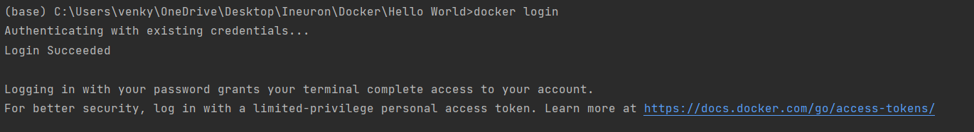

Used for login to the docker

1. Docker images

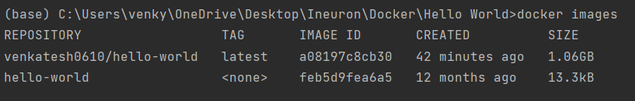

List out all the images which are present in the system

1. Docker ps



List out the containers which are running

1. Docker rmi -f image_id

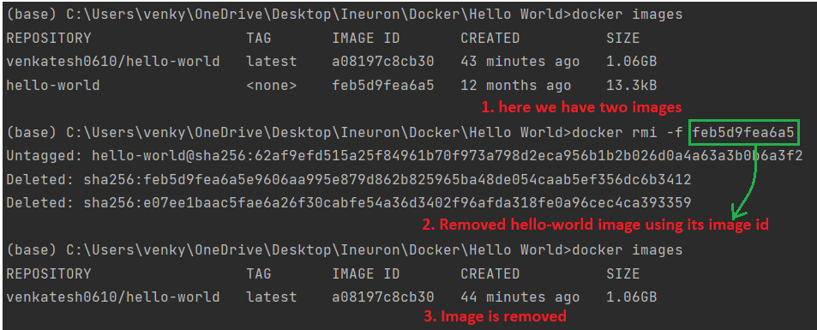

Used for removing the image which are created and -f is force.

1. Docker stop container_id

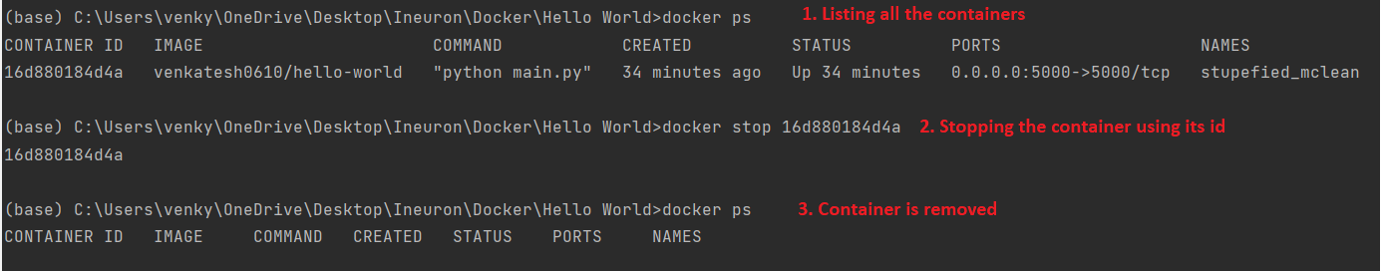

Used for stopping the container which is running

1. Docker build -t image_name .

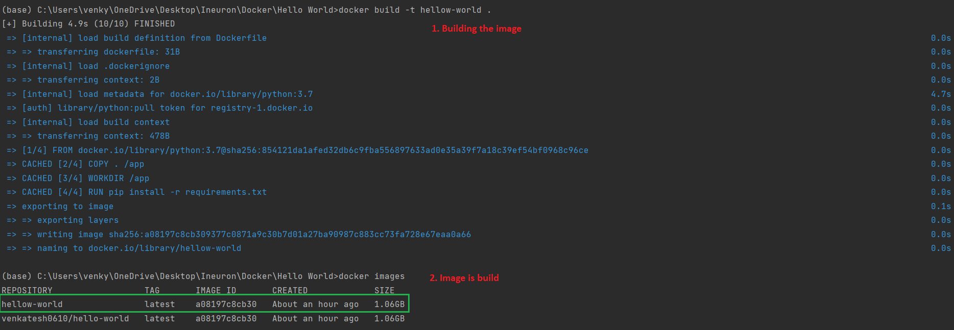

Creating the image where -t is a tag and . refers to current directory

1. Docker run -d -p host_port:local_port image_name

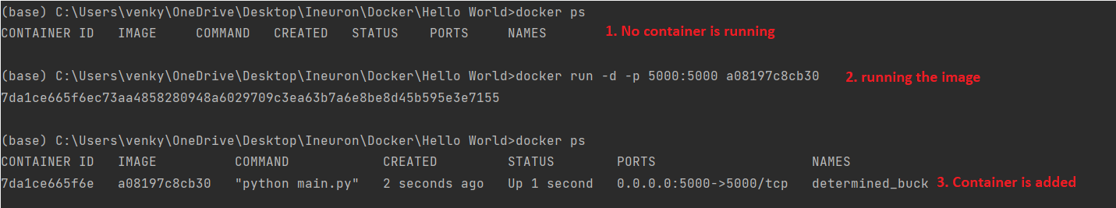

Used for running the created images where -d is ditach mode(which make sure the application run un the backend) and -p refers to the port.

1. Docker push username/image_name:tag

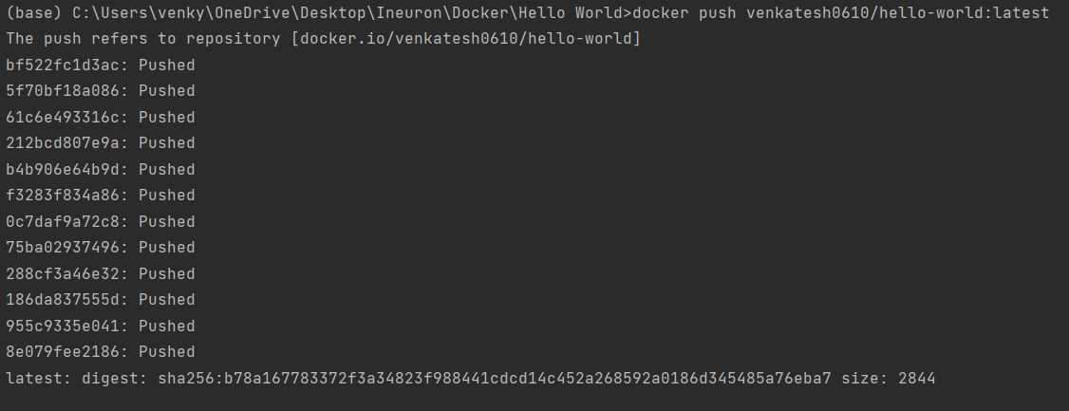

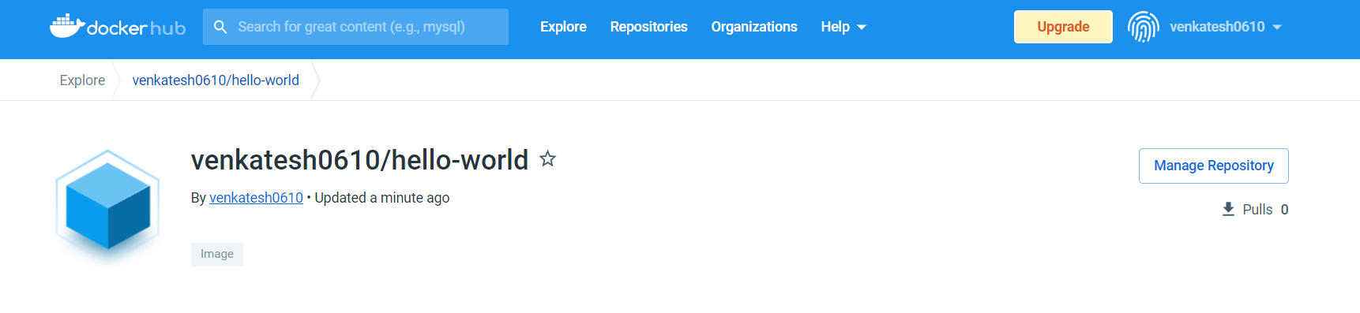

For pushing the locally created image to the docker hub we make use it.

1. Docker pull image_id

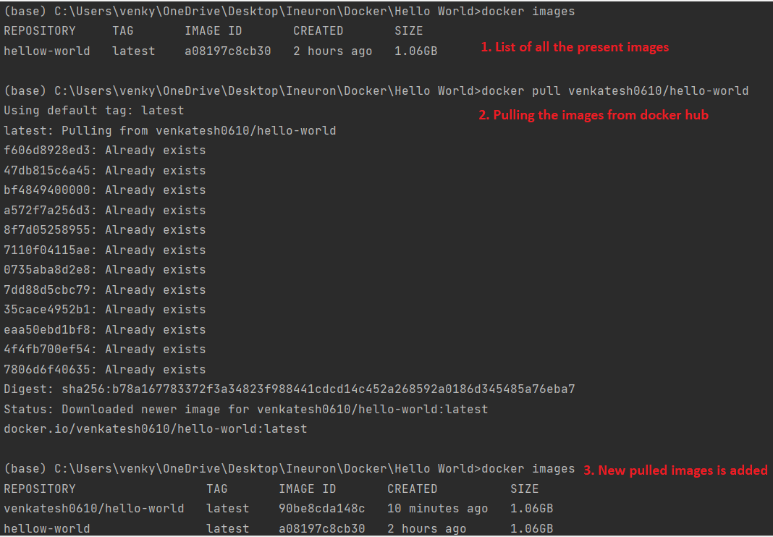

For pulling any image which is present in the docker hub we make use of this command.

1. Docker logs container_id

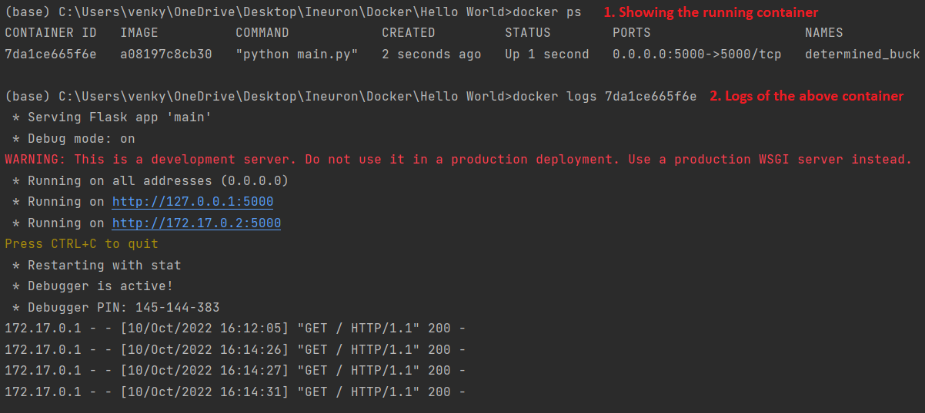

For getting the logs of the container which we run previously.

**Assignment 2**

[Hello World Docker Image](https://hub.docker.com/_/hello-world) Run Hello World Docker Image Locally.

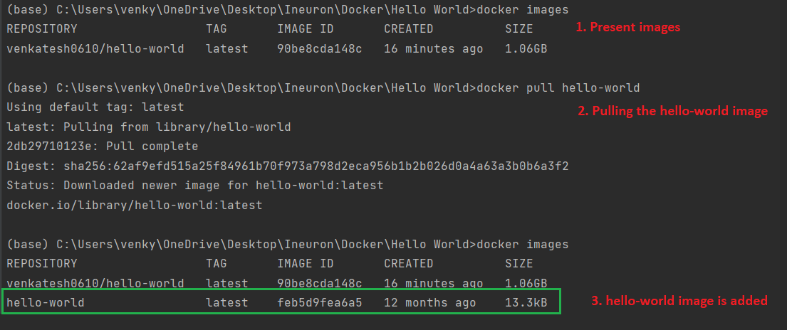

**Assignment 3**

Create a hello world fastapi application. Create a Dockerfile for your fastapi hello world application. Build Docker image using Docker file. Run docker image build in previous step. Push your Docker image to Docker Hub

* Create a hello world fastapi application.

Folder Structure:

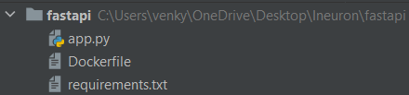

app.py

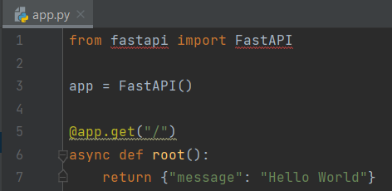

**Line 1** : Imported the fastapi package

**Line 3** : Created the instance of FasrAPI

**Line 5** : Add the path operation decorator

**Line 6** : Path operation function

* Create a Dockerfile for your fastapi hello world application.

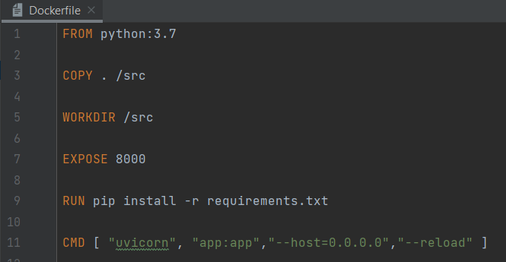

* Build Docker image using Docker file.

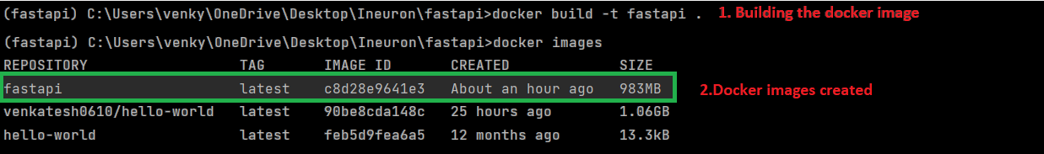

* Run docker image build in previous step.



Output in local browser:

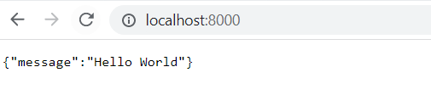

* Push your Docker image to Docker Hub